Lutheran Heritage Foundation
Who is My Neighbor? Bible Books for Immigrant Outreach
$ 5,500
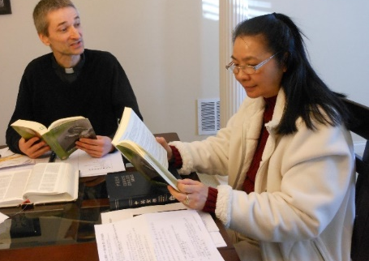
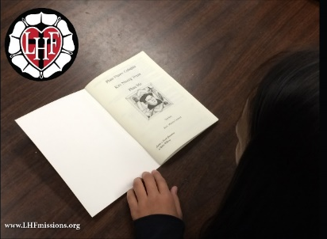

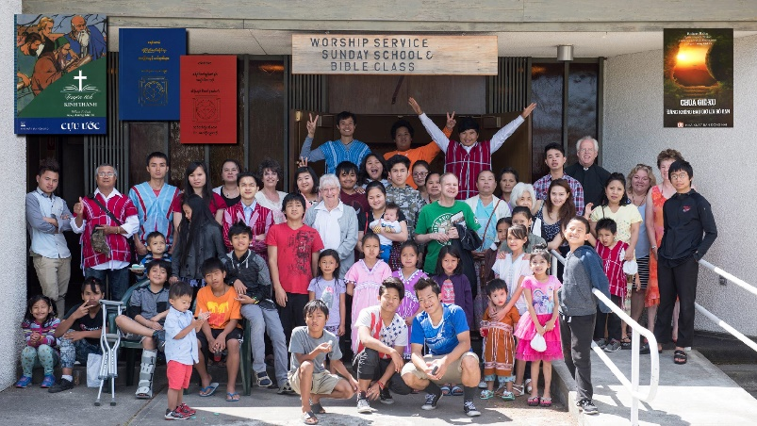

Funding from the LWML Washington-Alaska District will provide at least 1,000 books like Luther’s Small Catechism, The Good News About Jesus, A Child’s Garden of Bible Stories, and other materials that introduce immigrant non-believers to Jesus Christ in a language they understand. This on-going program is fully functioning and already in use, giving Washington’s and Alaska’s church leaders and missionaries the tools they need to share the Good News of Jesus Christ with the immigrants in their neighborhoods.

2022-2024 Biennium – LWML Washington-Alaska District

